**Ideation Phase**

**Brainstorm & Idea Prioritization**

|  |  |
| --- | --- |
| Date | 01 July 2025 |
| Team ID | LTVIP2025TMID40229 |
| Project Name | HematoVision |
| Maximum Marks | 4 Marks |

**Brainstorm & Idea Prioritization :**

# Problem Understanding

* Manual classification is time-consuming and error-prone.
* Need for quick, reliable diagnosis in hospitals and rural labs.
* Can deep learning assist medical professionals?

# Solution Ideas

|  |
| --- |
|  |
| Focus on 6 Blood Cell Types |
| Eosinophil. |
| |  |  | | --- | --- | | Auto-Predict with  Confidence | Return class + confidence %. | | Exportable Reports | Enable saving results as PDF/CSV. | | Mobile Version | Use TensorFlow Lite to build an app for rural health workers. | | Grad-CAM Heatmaps | Visualize prediction focus areas for transparency. | | API Endpoint | Allow hospitals to send images via REST API. | | Feedback System | Let users correct wrong predictions to improve the model. | | Real-Time Classification | Direct input from digital microscope cameras. | |

# User-Centered Features

* Support for high-resolution microscope images
* Simple upload and click-based UI
* Support for edge deployment (low power devices)
* Multi-language or local-language interface (for rural use)

# Creative Add-ons (Future Scope)

* AI-generated lab reports
* QR code-based results download
* Voice-based diagnosis description
* Integration with Electronic Health Records (EHR)

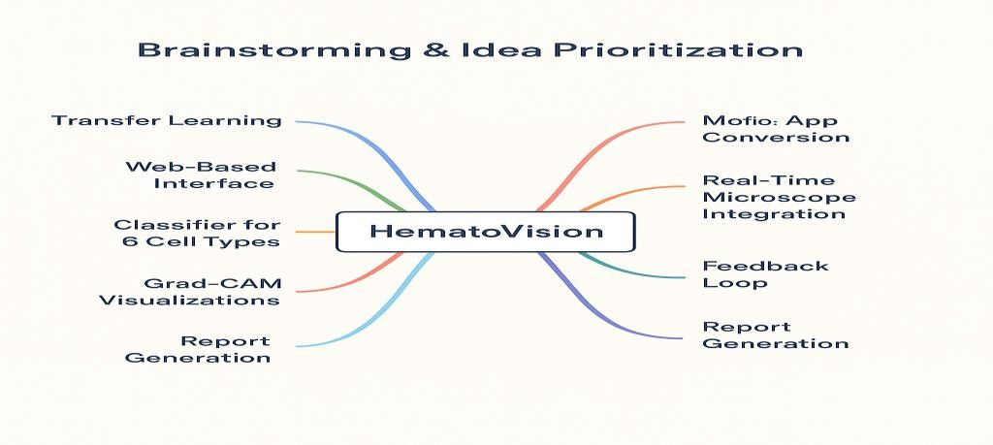

# Step-1: Team Gathering, Collaboration and Select the Problem Statement

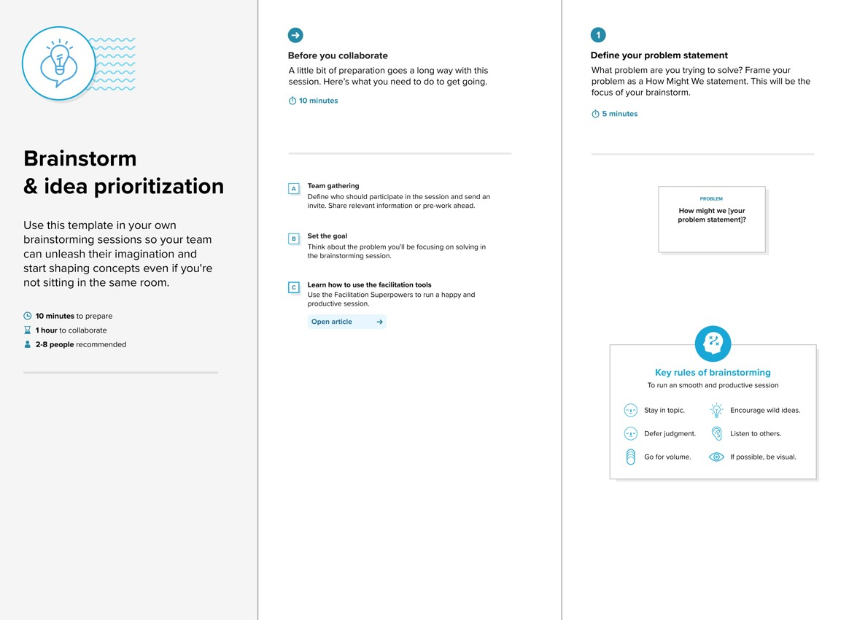

**Step-2: Brainstorm, Idea Listing and Grouping**

